# Exercise: HTML Structure

## Navigation Bar

Create a Web page, holding like the following navigation bar:

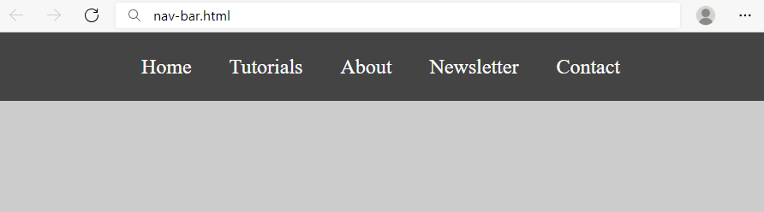

Use the texts from the filesite-texts.txt.

Create two files: nav-bar.html and nav-bar.css.

### Requirements

* <body>
  + Margin: 0px;
  + Padding: 0px;
  + Background Color: #CCCCCC;
* <nav>tag as container
* <ul> tag for unordered list
  + Background Color: #444;
  + Center the text
  + Padding: 0px;
  + Margin: 0px;
  + list-style:none;
* <li> tag for list item
  + Text size: 24px;
  + Line Height: 40px;
  + Height: 40px;
  + Padding: 20px;
* <a> tag for hyperlink
  + text-decoration: none;
  + Text-Color: #ffffff;

### Hints

Use:

* <li> with display:inline-block;

## Page Content

Create a Web page like the show below, using the text from the filesite-texts.txt.

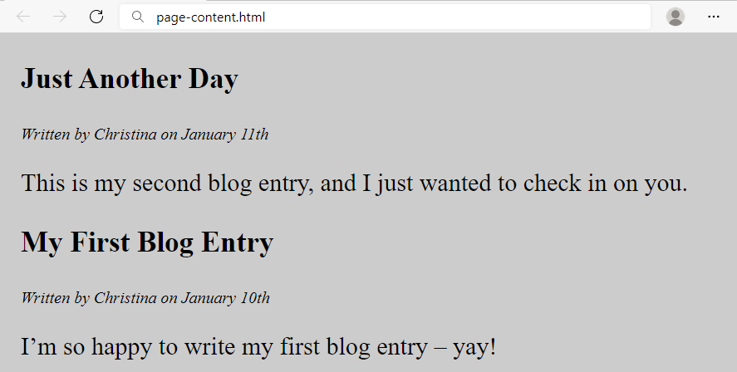

Create two files: page-content.htmlandpage-content.css**.**

### Requirements

* <section>as a container
* <article>tag for content
  + <header> with:
    - <h1>Text size: 28px;
    - <p>Font Style: **italic;**
* Paragraph
  + Text size: 24px;
* <body>
  + Margin: 0px;
  + Padding:0px;
  + Background color: **#CCCCCC;**
* **<section>**
  + Margin Left: 20px;

## Semantic Tags

Create a web page like the following:



Use the texts from the filesite-texts.txt.

Create files: index.htmlandstyles.css.

### Requirements

HTML:

* The title should be "**Semantic Tags**"
* Add header tag for the header section
  + Use h1 tag for the heading
* Add main tag for the main content
  + Create two paragraphs inside (p tag)
* Use footer tag for the last section
  + Create two paragraphs inside (p tag)

The CSS in the example above uses:

* **padding**: 15px, 5px 15px
* **background colors**: #f9f7cf, #f2dcbb
* **width**: 480px

### Hints

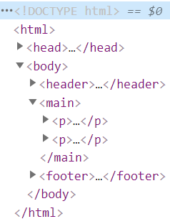

## Semantic Article Page

Create a web page like the following:

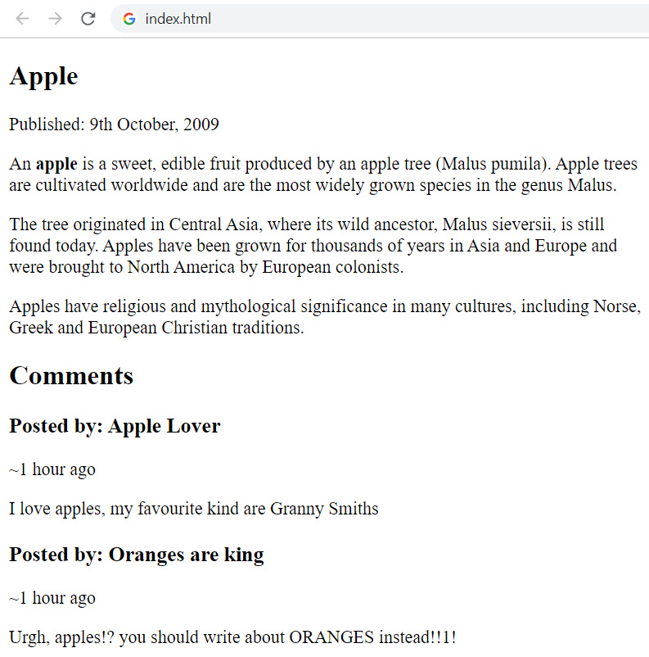

Add CSS to make the Web page look better, like this:

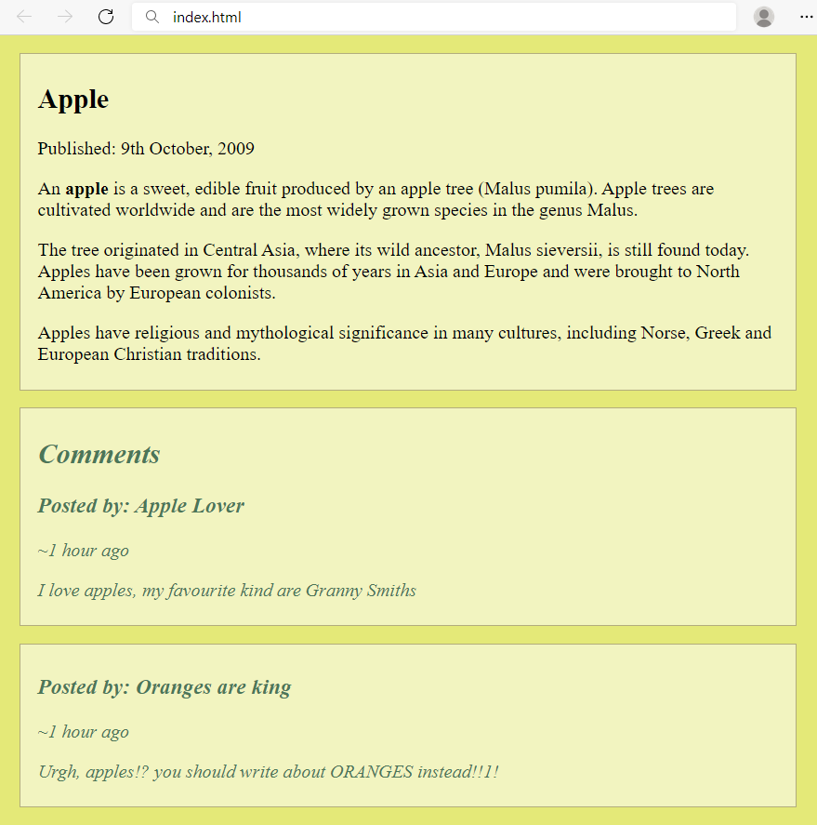

Use the texts from the filesite-texts.txt.

Create files: index.htmlandstyles.css.

### Requirements

* The title should be "**Semantic Article Page**"
* Use article tag to create an article
  + The article has header with h1 heading and a **paragraph** for the published date inside
* Use p tag to create 3 paragraphs after the **header**.
  + The paragraphs contain the article content *(info for apple)*
  + Use **b** tag where is needed
* Use section tag to create the "**Comment section**"
  + Add **two articles** inside the section
  + Each **article** has a **heading (h2)** for the **title**
  + Each **article** has **two paragraphs** for the **time** and the **comment**

Used CSS in the example above:

* padding: 5px 15px;
* font-style: italic
* color: #5c6e91
* background colors: #f2f4c0, #e4e978, #4c7658;
* width: 700px
* border: 1px solid #b2ad7d;
* margin: 15px 10px;

## Simple Website

Using the navigation bar and page content from the previous two exercises, create a Web page like the following:

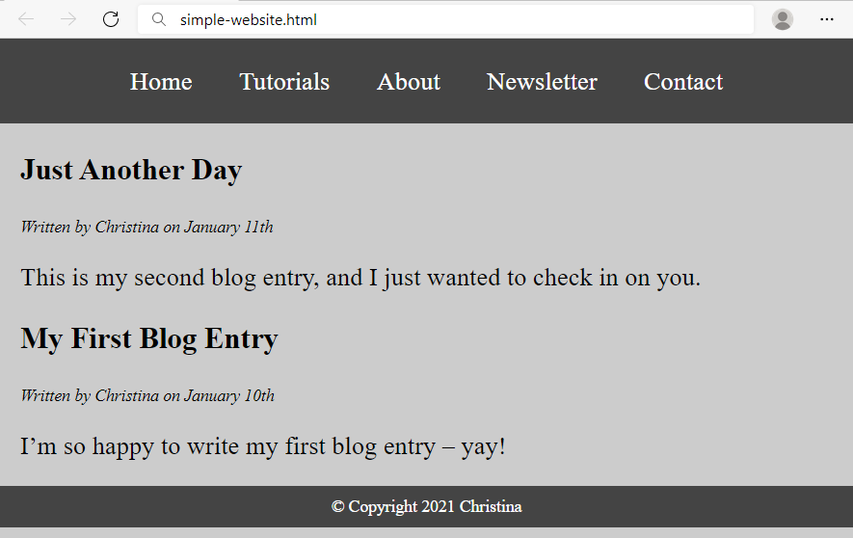

Use the texts from the filesite-texts.txt.

Create two files: simple-website.htmlandsimple-website.css.

### Requirements

* Use the **HTML** and **CSS** from previous two problems
* <footer> tag
  + Background color: #444;
  + <p> tag for text
  + Text Color: #fff;
  + Center the text
  + Padding: 10px

### Hints

Use:

* &copy;for copyright symbol

## Semantic Blog Layout

Create a **blog layout page**, which holds **header**, **footer** and **main**. The **main** should hold two **sections**, each holding two **articles**. It should look like this (without any styling):

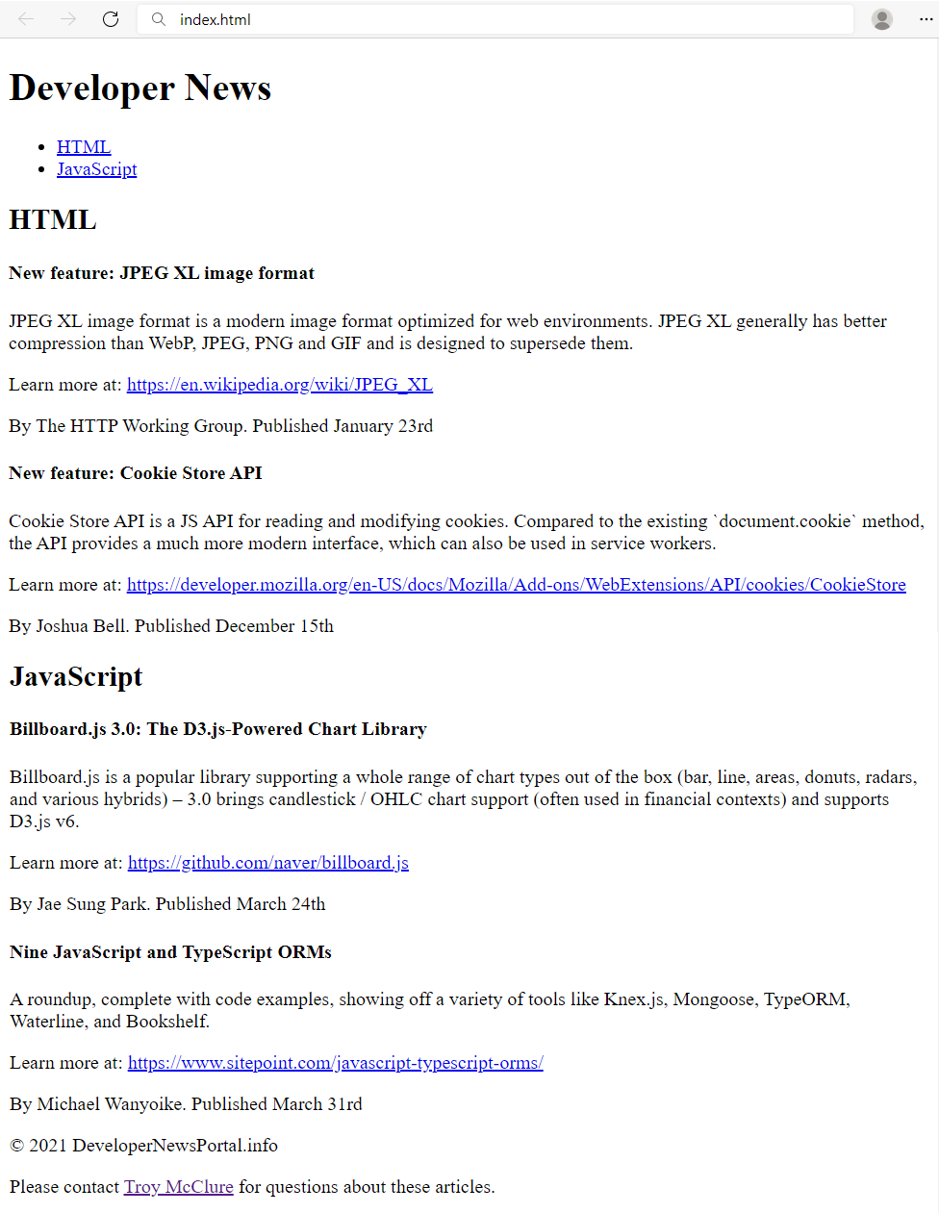



Use the texts from the filesite-texts.txt.

Create files: index.htmlandstyles.css.

### Requirements

* The title should be "**Semantic Blog Layout**"
* Use header tag for the header section
  + Use h1 tag for the heading
  + Use nav tag for the navigation with an unordered list (ul) inside
    - Create two **list** items with **anchor** (a) tags inside
* Use main tag for the page main content
  + Create two **sections** in the main. Each section has:
    - A **header** with h2 heading
    - Two **articles** with h4 heading and three p tags inside
    - For the dates use time tag
* Use footer tag with **two** paragraphs Inside
  + Use **anchor** tag for the name in the last sentence

### Add CSS Styling

Add **CSS styling** to make the blog look better, like at the following screenshot:

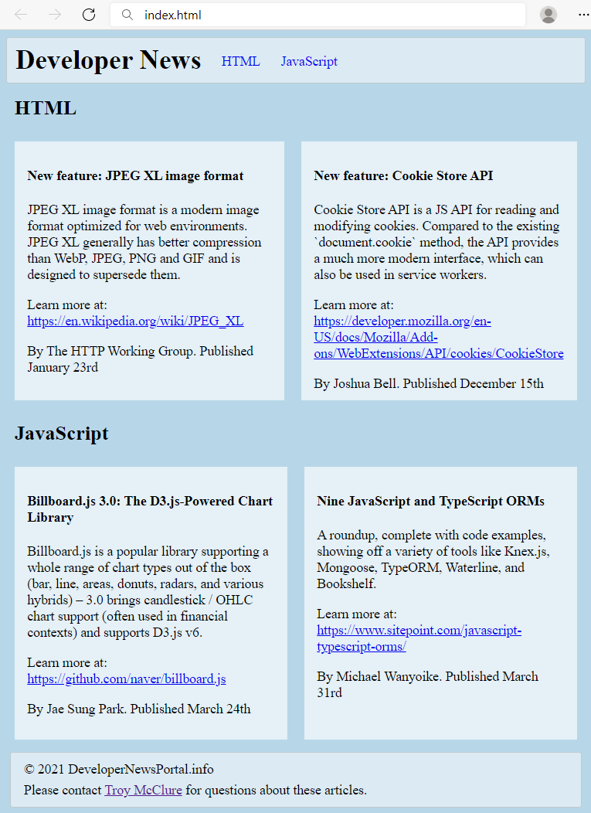

Create files: index.htmlandstyles.css.

Use the following **CSS styles** to make your HTML look like at the screenshot:

|  |
| --- |
| header {      border-radius: 3px;      padding: 8px 10px;      background-color: #dceaf4;      border: 1px solid #bfcacb;  }  header * {      display: inline;      vertical-align: middle;  }  nav ul {    margin: 0;    padding: 10px;  }  nav li {    margin:10px;  }  nav li a {      text-decoration: none;  }  body{      background-color:#b7d7e8;  }  section h2 {      margin: 15px 10px;  }  article {      display: table-cell;      width: 50%;      padding: 10px 15px;      background-color: #e5f0f7;      border: 10px solid #b7d7e8;  }  footer {      margin: 5px;      padding: 5px 10px;      border-radius: 3px;      background-color: #dceaf4;      border: 1px solid #bfcacb;  }  footer p {      margin: 5px;  } |